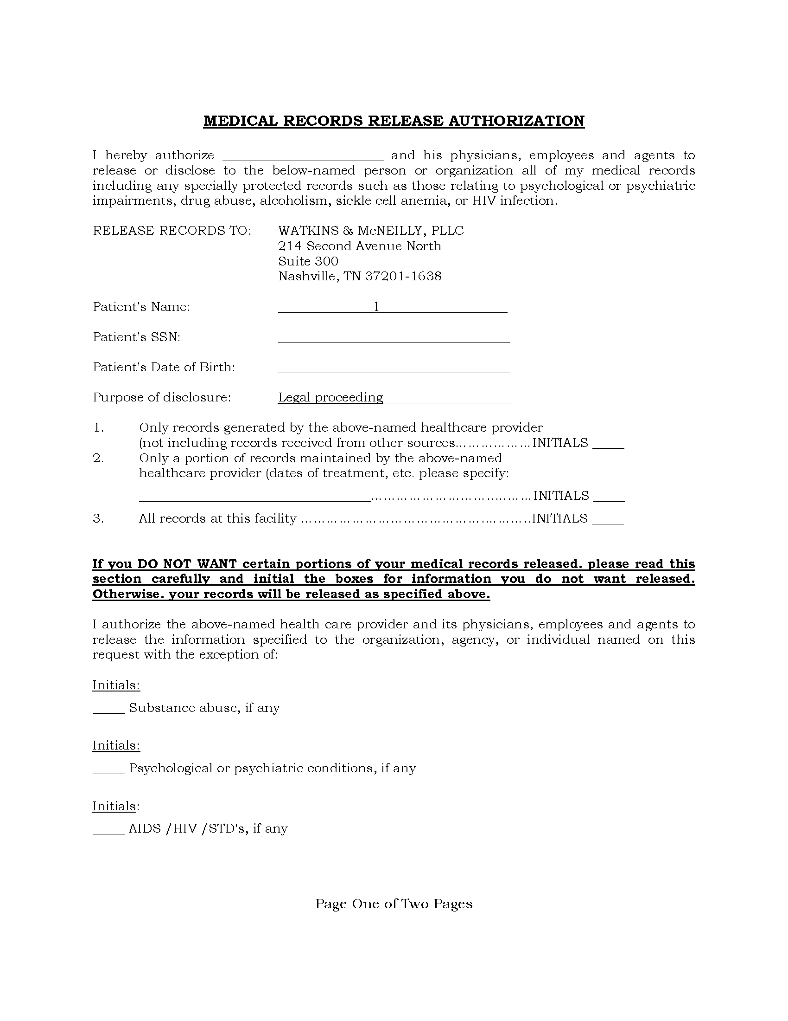
University of Michigan Hospital and Health Center
Batman
xxx-xx-5555
01/01/1979
Order Number: 01-29018-002
Axiom Requisition
2869 Jolly Rd
Okemos, MI 48864
Phone: 877-886-5090 Fax: 517-886-4116
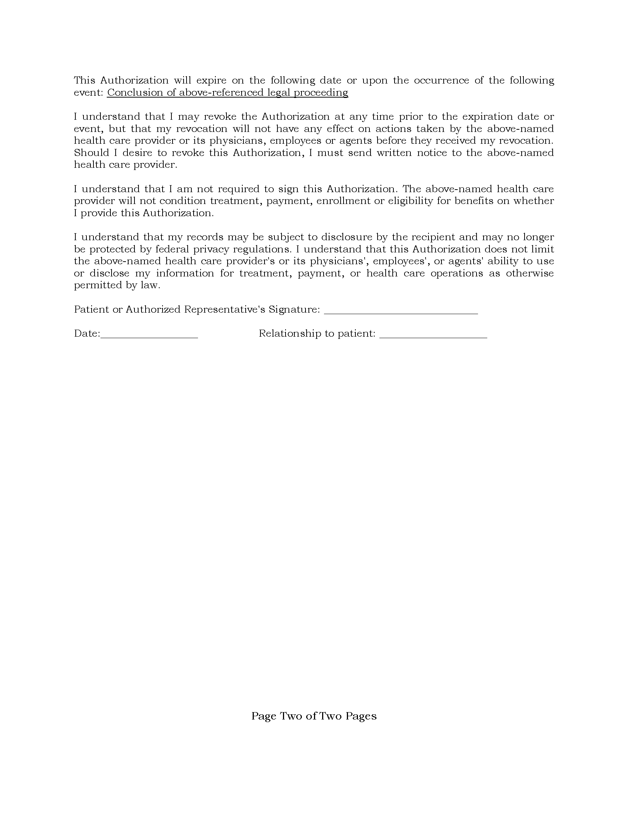
Order Number: 01-29018-002

